IMPLEMENTATION
MODULES:
- Dataset
- Importing the necessary libraries
- Retrieving the images
- Splitting the dataset
- Building the model
- Apply the model and plot the graphs for accuracy and loss
- Accuracy on test set
- Saving the Trained Model

MODULES DESCSRIPTION:
Dataset:
In the first module of Blood Cancer Detection and Classification using Deep Learning, we developed the system to get the input dataset. Data collection process is the first real step towards the real development of a machine learning model, collecting data. This is a critical step that will cascade in how good the model will be, the more and better data that we get, the better our model will perform. There are several techniques to collect the data, like web scraping, manual interventions. Our dataset is placed in the project and it’s located in the model folder. The dataset is referred from the popular standard dataset repository kaggle where all the researchers refer it. The dataset consists of 3242 images.
Dataset Kaggle Link:
https://www.kaggle.com/datasets/jayaprakashpondy/blood-cancer-dataset

The images contained within this dataset were meticulously generated within the bone marrow laboratory at Taleqani Hospital in Tehran, Iran. This comprehensive dataset encompasses a total of 3,242 Peripheral Blood Smear (PBS) images obtained from 89 patients under suspicion of Acute Lymphoblastic Leukemia (ALL). These images were meticulously prepared and stained by highly skilled laboratory personnel.
The dataset is categorized into two distinct classes: benign and malignant. The benign class encompasses hematogenous cells, while the malignant class comprises the ALL group, further subdivided into three distinct subtypes of malignant lymphoblasts: Early Pre-B, Pre-B, and Pro-B ALL.
All the images were captured using a Zeiss camera affixed to a microscope, providing a magnification of 100x, and were subsequently saved in JPG format. To arrive at the definitive classification of cell types and subtypes, a specialist utilized the advanced flow cytometry tool, ensuring the accuracy and reliability of the dataset's annotations.

Importing the necessary libraries:
In this project, we have chosen to utilize the Python programming language as our primary tool. Our initial step involves importing essential libraries to facilitate various tasks. These libraries include Keras, which will aid in constructing the core model, as well as Scikit-Learn (sklearn), which we will employ to partition the data into training and testing sets. Additionally, we will utilize the Python Imaging Library (PIL) to convert the images into numerical arrays. To assist with data manipulation and analysis, we will also make use of other widely-used libraries such as Pandas, NumPy, Matplotlib, and TensorFlow.

Retrieving the images:
In this module we will retrieve the images from the dataset and convert them into a format that can be used for training and testing the model. This involves reading the images, resizing them, and normalizing the pixel values. We will retrieve the images and their labels. Then resize the images to (224, 224) as all images should have same size for recognition. Then convert the images into numpy array.

Splitting the dataset:
In this module, the image dataset will be divided into training and testing sets. Split the dataset into Train and Test. 80% train data and 20% test data. This will be done to train the model on a subset of the data, validate the model's performance, and test the model on unseen data to evaluate its accuracy. Split the dataset into train and test. 80% train data and 20% test data.

Building the model:
The concept of convolutional neural networks are very successful in image recognition. The key part to understand, which distinguishes CNN from traditional neural networks, is the convolution operation. Having an image at the input, CNN scans it many times to look for certain features. This scanning (convolution) can be set with 2 main parameters: stride and padding type. As we see on below picture, process of the first convolution gives us a set of new frames, shown here in the second column (layer). Each frame contains information about one feature and its presence in scanned image. Resulting frame will have larger values in places where a feature is strongly visible and lower values where there are no or little such features. Afterwards, the process is repeated for each of obtained frames for a chosen number of times. In this project I chose a classic MobileNetV2 model which contains only two convolution layers.
The latter layer we are convolving, the more high-level features are being searched. It works similarly to human perception. To give an example, below is a very descriptive picture with features which are searched on different CNN layers. As you can see, the application of this model is face recognition. You may ask how the model knows which features to seek. If you construct the CNN from the beginning, searched features are random. Then, during training process, weights between neurons are being adjusted and slowly CNN starts to find such features which enable to meet predefined goal, i.e. to recognize successfully images from the training set.

Between described layers there are also pooling (sub-sampling) operations which reduce dimensions of resulted frames. Furthermore, after each convolution we apply a non-linear function (called ReLU) to the resulted frame to introduce non-linearity to the model.

Eventually, there are also fully connected layers at the end of the network. The last set of frames obtained from convolution operations is flattened to get a one-dimensional vector of neurons. From this point we put a standard, fully-connected neural network. At the very end, for classification problems, there is a softmax layer. It transforms results of the model to probabilities of a correct guess of each class

MobileNetV2| CNN model
Architecture:
MobileNetV2 is a convolutional neural network architecture that seeks to perform well on mobile devices. It is based on an inverted residual structure where the residual connections are between the bottleneck layers. The intermediate expansion layer uses lightweight depthwise convolutions to filter features as a source of non-linearity. As a whole, the architecture of MobileNetV2 contains the initial fully convolution layer with 32 filters, followed by 19 residual bottleneck layers.

1. MobileNetV2 Convolutional Blocks
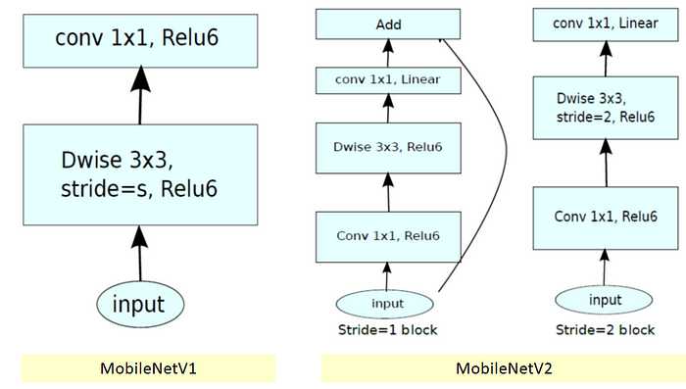
1.1. MobileNetV1
In MobileNetV1, there are 2 layers.
The first layer is called a depthwise convolution, it performs lightweight filtering by applying a single convolutional filter per input channel.
The second layer is a 1×1 convolution, called a pointwise convolution, which is responsible for building new features through computing linear combinations of the input channels.
ReLU6 is used here for comparison. (Actually, in MobileNetV1 tech report, I cannot find any hints that they use ReLU6… Maybe we need to check the codes in Github…), i.e. min(max(x, 0), 6) as follows:
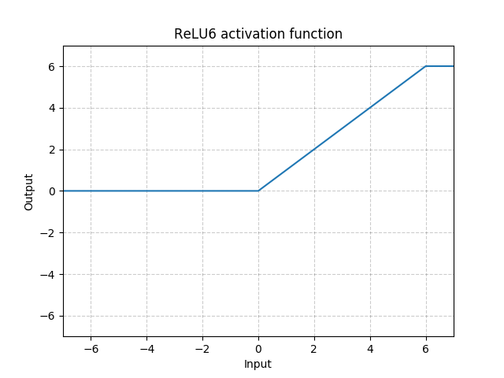
ReLU6
ReLU6 is used due to its robustness when used with low-precision computation, based on MobileNetV1.

In MobileNetV2, there are two types of blocks. One is residual block with stride of 1. Another one is block with stride of 2 for downsizing.
There are 3 layers for both types of blocks.
This time, the first layer is 1×1 convolution with ReLU6.
The second layer is the depthwise convolution.
The third layer is another 1×1 convolution but without any non-linearity. It is claimed that if ReLU is used again, the deep networks only have the power of a linear classifier on the non-zero volume part of the output domain.
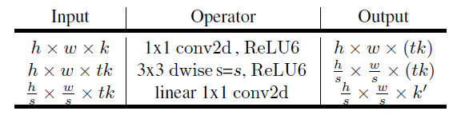
And there is an expansion factor t. And t=6 for all main experiments.
If the input got 64 channels, the internal output would get 64×t=64×6=384 channels.
2. Overall Architecture
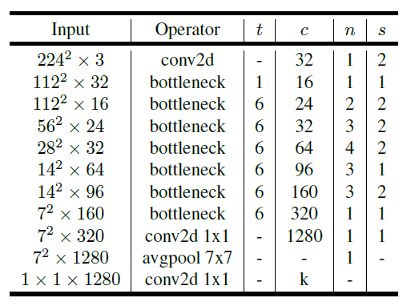

MobileNetV2 Overall Architecture
where t: expansion factor, c: number of output channels, n: repeating number, s: stride. 3×3 kernels are used for spatial convolution.
In typical, the primary network (width multiplier 1, 224×224), has a computational cost of 300 million multiply-adds and uses 3.4 million parameters. (Width multiplier is introduced in MobileNetV1.)
The performance trade offs are further explored, for input resolutions from 96 to 224, and width multipliers of 0.35 to 1.4.
The network computational cost up to 585M MAdds, while the model size vary between 1.7M and 6.9M parameters.
To train the network, 16 GPU is used with batch size of 96.
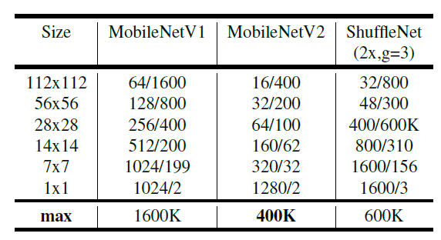
Number of Maximum Channels/Memory in Kb) at Each Spatial Resolution for Different Architecture with 16-bit floats for activation
3. Ablation Study
3.1. Impact of Linear Bottleneck
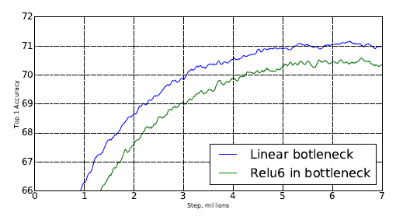
With the removal of ReLU6 at the output of each bottleneck module, accuracy is improved.
3.2. Impact of Shortcut
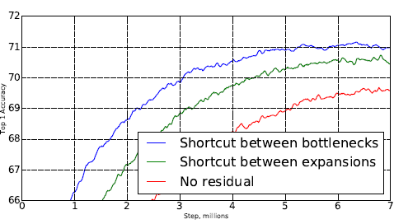
With shortcut between bottlenecks, it outperforms shortcut between expansions and the one without any residual connections.
4. Experimental Results
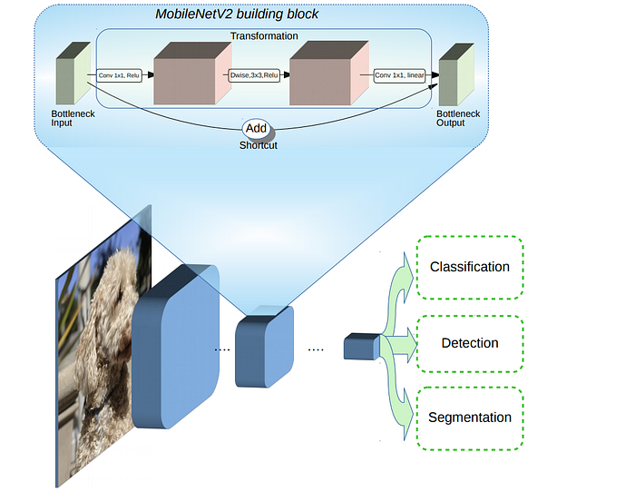
MobileNetV2 for Classification, Detection and Segmentation

4.1. ImageNet Classification
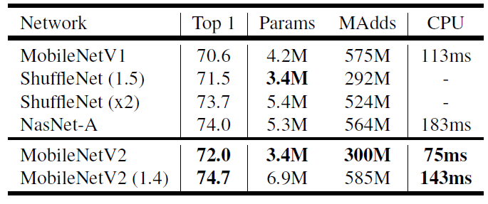
ImageNet Top-1 Accuracy
MobileNetV2 outperforms MobileNetV1 and ShuffleNet (1.5) with comparable model size and computational cost.
With width multiplier of 1.4, MobileNetV2 (1.4) outperforms ShuffleNet (×2), and NASNet with faster inference time.
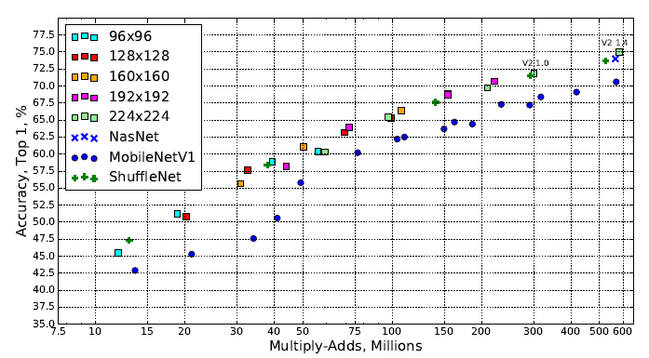
As shown above, different input resolutions and width multipliers are used. It consistently outperforms MobileNetV1.
4.2. MS COCO Object Detection
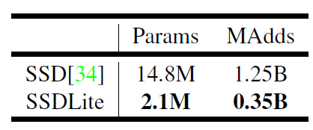
SSDLite
First, SSDLite is introduced by modifying the regular convolutions in SSD with depthwise separable convolutions (MobileNetV1 one).
SSDLite dramatically reduces both parameter count and computational cost.
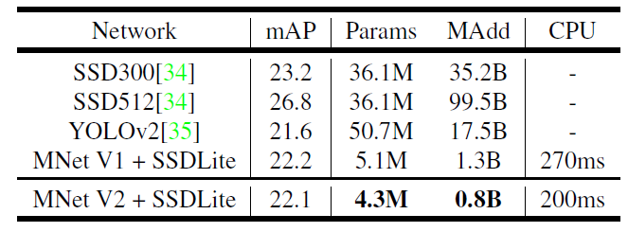
MS COCO Object Detection
MobileNetV2 + SSDLite achieves competitive accuracy with significantly fewer parameters and smaller computational complexity.
And the inference time is faster than MobileNetV1 one.
Notably, MobileNetV2 + SSDLite is 20× more efficient and 10× smaller while still outperforms YOLOv2 on COCO dataset.
4.3. PASCAL VOC 2012 Semantic Segmentation
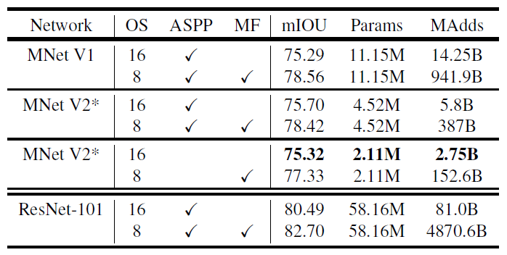
PASCAL VOC 2012 Validation Set
Here, MobileNetV2 is used as feature extractor for DeepLabv3.
With the disabling of Atrous Spatial Pyramid Pooling (ASPP) as well as Multi-Scale and Flipping (MP), also changing the output stride from 8 to 16, mIOU of 75.32% is obtained, with far low of model size and computational cost.

Apply the model and plot the graphs for accuracy and loss:
Once the model is built, it will be applied to the validation set to evaluate its accuracy and loss. The accuracy and loss will be plotted as a function of the number of epochs to visualize the performance of the model. We will compile the model and apply it using fit function. The batch size will be 1. Then we will plot the graphs for accuracy and loss. We got an average training accuracy of 98.00%.

Accuracy on test set:
After training and evaluating the model on the validation set, the accuracy of the model will be assessed on the test set. The accuracy on the test set will be an important metric for evaluating the model's performance. We got an accuracy of 96.00% on test set.

Saving the Trained Model:
Once you’re confident enough to take your trained and tested model into the production-ready environment, the first step is to save it into a .h5 or .pkl file using a library like pickle.
Make sure you have pickle installed in your environment.
Next, let’s import the module and dump the model into .h5 file.

